Coursera Capstone Project

-by Jayant Agarwal

“The Battle of Neighborhoods”

* Analysis on Restaurants in New York

Introduction:

With an estimated population of 8,622,698 , NEW YORK is the most densely populated city in the United States.

New York city consists of 5 Boroughs and each borough has many Neighborhoods. New York City are well known, with the city having

three of the world's 10 most visited tourist attractions in 2013 and receiving a record 62.8 million tourists in 2017.

Tourism

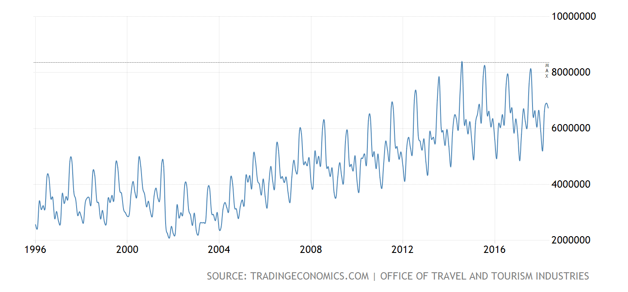

The Plot above shows the huge increase in number of tourists each year. If we can find out , what type of restaurants have most demand

and how many of them are easily available to the tourists , as well as to the citizens of the city, it would be very much helpful for the

investors in this business , not only this , but it would also help the government to attract more tourists each year and grow their

economy.

Preliminary Analysis:

Most common(maximum in number) restaurants in all Neighborhoods.



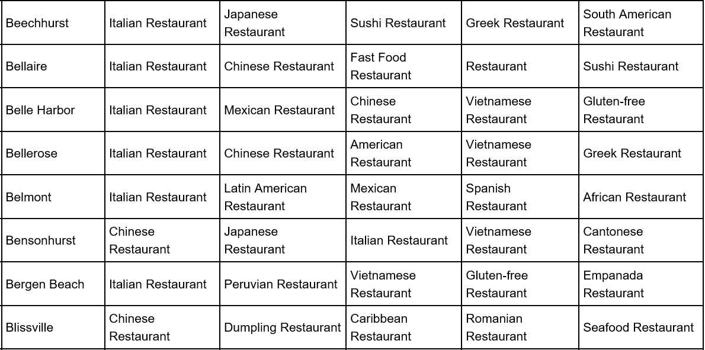

The above data(part of analysis) shows the most common restaurants in each Neighborhoods.

While Italian is at the top of the list in most Neighborhoods, Chinese too , holds the position of being at the top of some

neighborhoods.

Secondary Analysis:

Top 2 common restaurants in Bronx are Fast Food and Italian

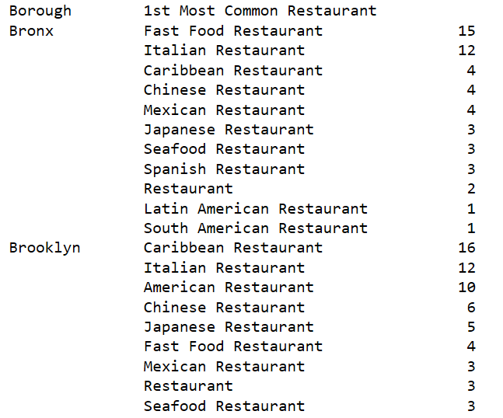

Top 2 common restaurants in Manhattan are Italian and American

Top 2 common restaurants in Broooklyn are Caribbean and Italian

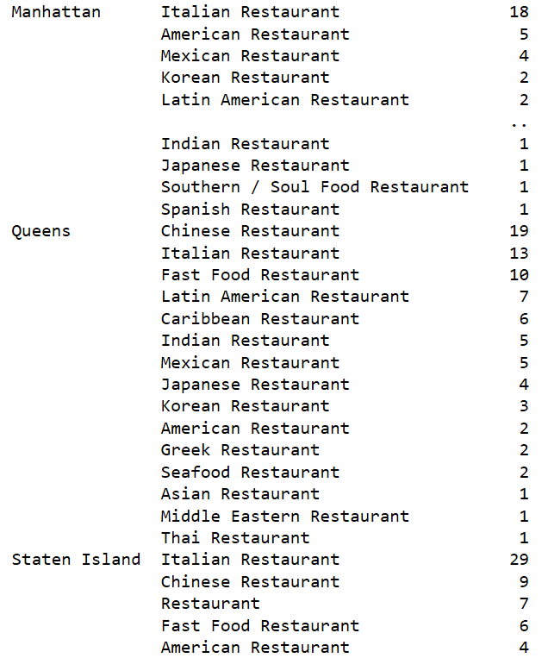

Top 2 common restaurants in Bronx are Italian and Chinese

Top 2 common restaurants in Queens are Chinese and Italian

Among all these data, one thing is common, ITALIAN RESTAURANTS , that are present in great number in every Borough and most of the

Neighborhoods.

SUGGESTION:

Brooklyn 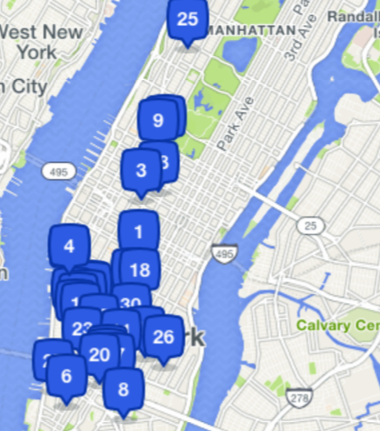

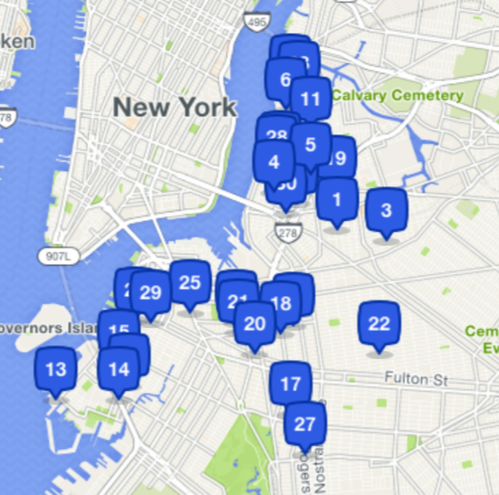

Manhattan

As an investment area,

* Bronx is good for starting restaurants other than Fast Food and Italian, as it has high competition and very much common

in Bronx and its neighborhoods.

* Brooklyn is good for starting restaurants other than Caribbean and Italian, as it has high competition and very much common

in Brooklyn and its neighborhoods.

* Manhattan can be good for starting restaurants other than Italian, as it has high competition and very much common

in its neighborhoods. Manhattan can be suggested for Mexican, Spanish, Japanese, Indian, because these are very much uncommon

in its neighborhoods.

* Similarly, Manhattan can be suggested for Thai, Asian, Japanese, Korean, and many more, due to their low count and hence low competition in its neighborhoods.
* Finally, Staten Island can be good for all types of Restaurants , except Italian and Chinese.